**CHAPTER 3**

**SYSTEM DESIGN AND IMPLEMENTATION**

Since SaaS is low cost, flexible and can work anywhere, the adoption rate of SaaS have been increased obviously. To have the beauty of SaaS, developers have to think about how to generalize different types systems. This system provide two types of systems that support two types of companies, ‘Distribution companies’ (e.g. Beauty Diary cosmetic store) and ‘Transportation companies’ (e.g. Mandalar Min Express).

**3.1 System Design**

To generalize two or more different types of systems, the main difficulty is to generalize the database. This system use non-relational database to be flexible and scalable. Because of non-relational database, no fixed database schema would be needed anymore.

For distribution companies, there are four built-in user roles.

1. Admin
2. Sale/Order Agent
3. Store Manager
4. Delivery Agent

For transportation companies, there are three built-in user roles.

1. Admin
2. Sale/Order Agent
3. Ticket Generator

Company registration process can only be done by admin of the system. For distribution companies, employee management, customer management, inventory management, order management and delivery management services are supported. For transportation companies, employee management, ticketing services are supported. Authorities for each user type are shown in Table 3.1.

**Table 3.1 Authorities of Distribution Company**

|  |  |  |  |  |
| --- | --- | --- | --- | --- |
|  | Creation | Inventory Modules | Order Module | Delivery Module |
| Admin | Yes | Yes | Yes | Yes |
| Sale/Order Agent | Can create customer only | View only | Yes | **-** |
| Store Manager | **-** | Yes | **-** | **-** |
| Delivery Agent | **-** | **-** | **-** | Yes |

**Table 3.2** **Authorities of Transportation Company**

|  |  |  |  |
| --- | --- | --- | --- |
|  | Creation | Ticket Generating | Booking Module |
| Admin | Yes | Yes | Yes |
| Ticket Generator | **-** | Yes | **-** |
| Sale/Order Agent | **-** | **-** | Yes |

Create Product

Start

Company Information

Register Company

Employee Information

Sign up Employee

Product Information

End

**Figure** **3.1 Flow Chart for Admin of Distribution Company**

End

No

Yes

Stock In Items

Start

Warehouse

Stock out items?

Warehouse

Stock Out Items

Stock transfer items?

Warehouse

Stock transfer

No

Yes

**Figure 3.2** **Flow Chart for Store Manager of Distribution Company**

Yes

Print or Download Invoice PDF

End

Yes

Yes

Send order to Delivery Module

Need Delivery?

No

Start

Products

Order

In stock?

Cancel Order

No

**Figure 3.3 Flow Chart for Sale/Order Agent of Distribution Company**

Yes

Start

Delivery Fees

Deliver Items

Print or Download Invoice PDF

End

**Figure 3.4 Flow Chart for Delivery Agent of Distribution Company**

Create Bus

Start

Company Information

Register Company

Employee Information

Sign up Employee

Bus Information

End

**Figure 3.5 Flow Chart for Admin of Transportation Company**

Start

Bus number, Departure date, time, price

Generate Tickets

End

**Figure 3.6 Flow Chart for Ticket Generator of Transportation Company**

Start

Departure date, routes

Search Bus

Choose Bus, seat and fill passenger information

Book ticket

Print Ticket PDF

End

**Figure 3.6 Flow Chart for Ticket Generator of Transportation Company**

**3.2 System Implementation**

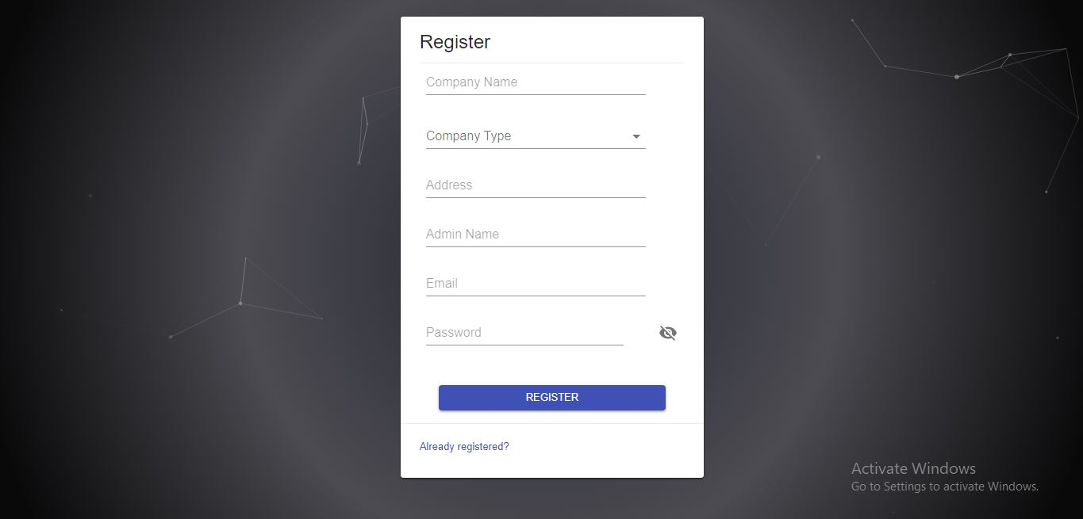This system provide a digital platform which provide a fully functional features of distribution companies and transportation companies in SaaS (Software as a Service) model. When the user want to use this system, he must register his company name, company type ( Transportation company or Distribution company ), address, admin name, email and password as shown in Figure 3.1. After registration, user can log in using the submitted email and password.

**Figure 3.1 Register Page**

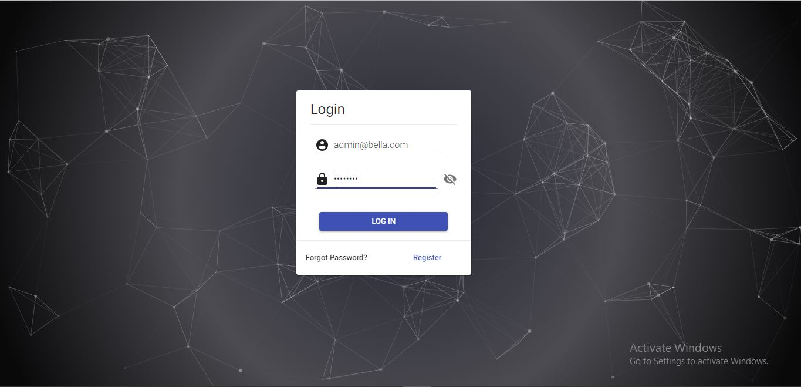

**Figure 3.2 Login Page**

3.2.1 Distribution Company

Because this system is developed in SaaS (Software as a Service) model, any types of distribution companies such as cosmetics stores (e.g. Beauty Diary, Bella cosmetics), Beverage companies (e.g. Asia soft drink factory, Alpine Purify Water Factory), Smart phones distributors (e.g. Anycall mobile, Mobile Mother) can use this system. This system provides the following services.

1. User Management (Employee management)
2. Warehouse Management (Store Management)
3. Customer Management
4. Inventory Management
5. Order Management
6. Delivery Management
   * 1. User Management (Employee management)

After registration, admin can log into the system. Then he can add other admins, sale/order agents, store managers and delivery agents. When creating a new sale/order agent, user can assign one or many warehouses. Then the created sale/order agent can order products that is available in warehouse he was assigned. Admin can also edit and delete users (employees).

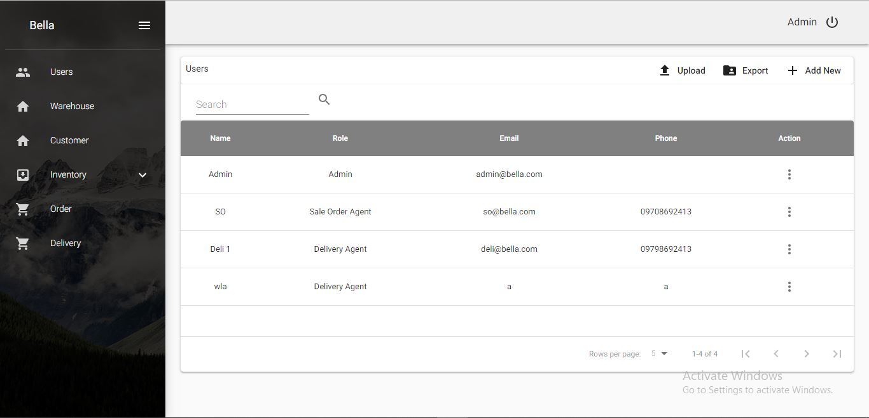

**Figure 3.3 User List**

* + 1. Warehouse Management (Store management)

Admin can add warehouses (stores) to the system. He can also edit warehouses (name, code, address) and delete warehouse. Admin can also view stock of each inventory.

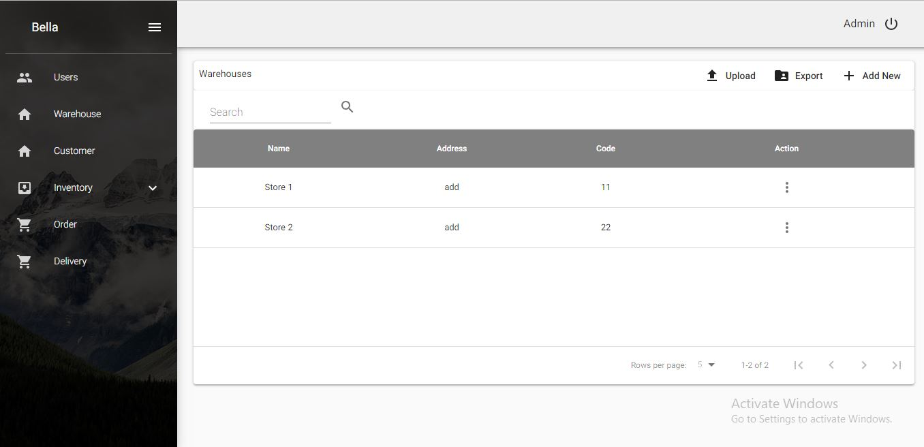

**Figure 3.4 Warehouse List**

3.2.4 Customer Management (Optional)

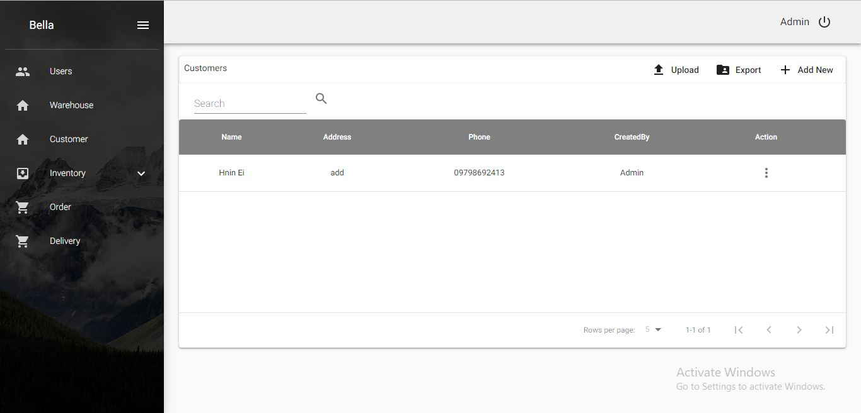Admin can add customers to the system. He can also edit customers (name, code, address) and delete customers.

**Figure 3.5 Customer List**

3.2.5 Inventory Management

Because this system is developed in SaaS model, user can customize their products in the system. There can be two types of products, products with variants and products with no variants. For the first one, user have to submit product name and brand in first step, price and stock keeping unit (which is a unique identifier of each product) in second step and maximum and minimum threshold of the product.

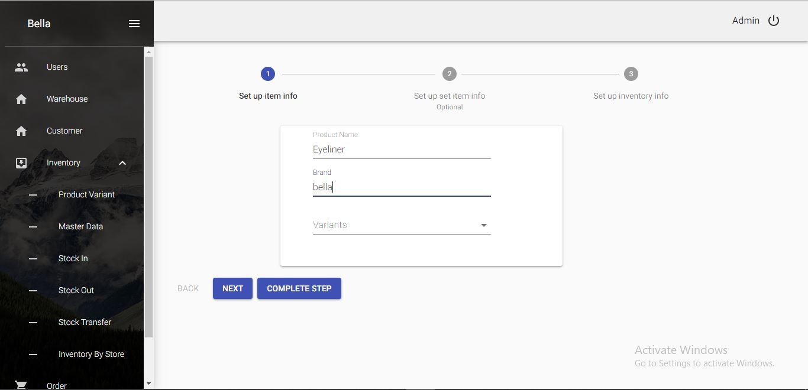

**Figure 3.6** **Step 1 of product creation with no variant**

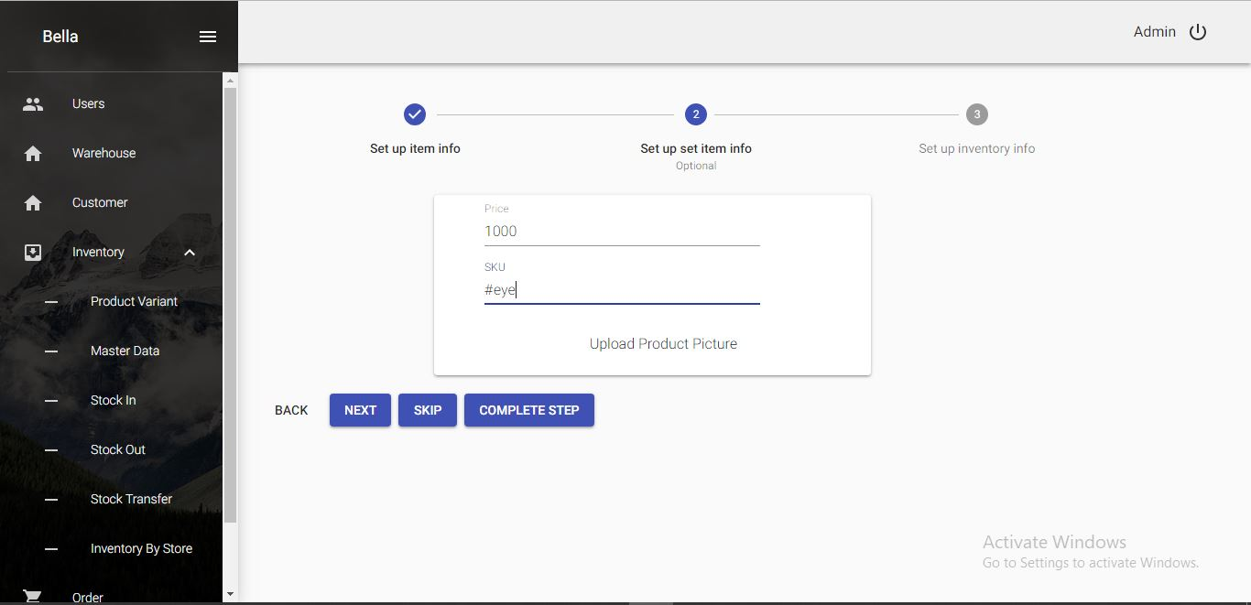

**Figure 3.7 Step 2 of product creation with no variant**

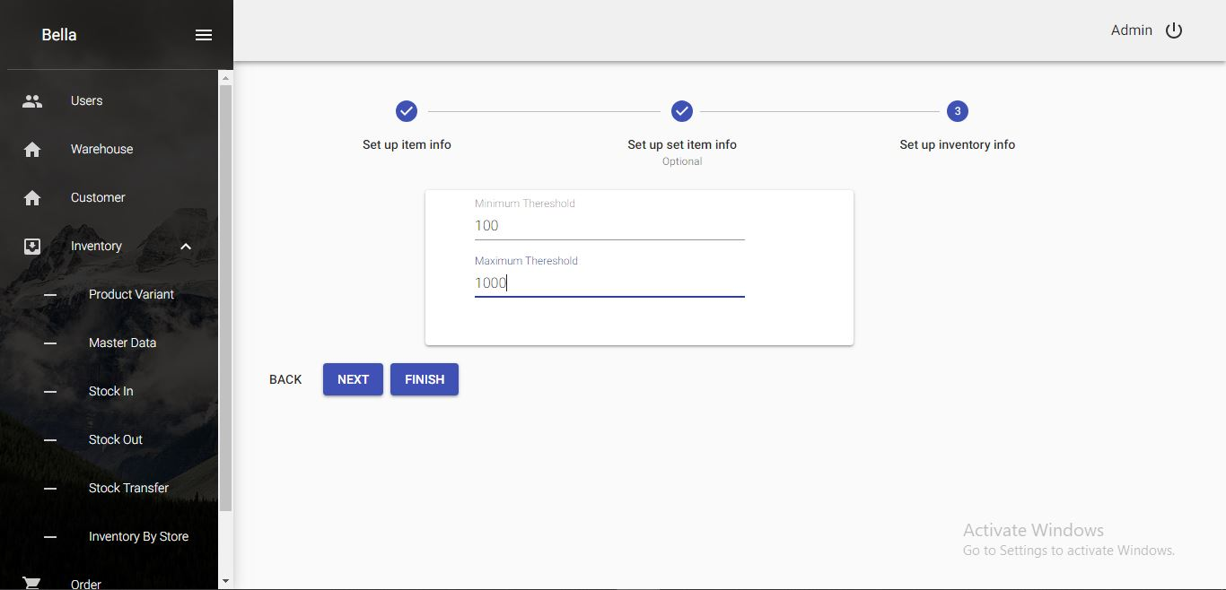

**Figure 3.8 Step 3 of product creation with no variant**

For creation of product with variants, user have to create product variants (such as size, colors, etc.). Then, user have to submit product name and brand in first step as mentioned above. For the second step, user have to fill price, stock keeping unit and variant value for each product variant. For inventory control information, maximum and minimum threshold of the product have to be filled in third step of product creation.

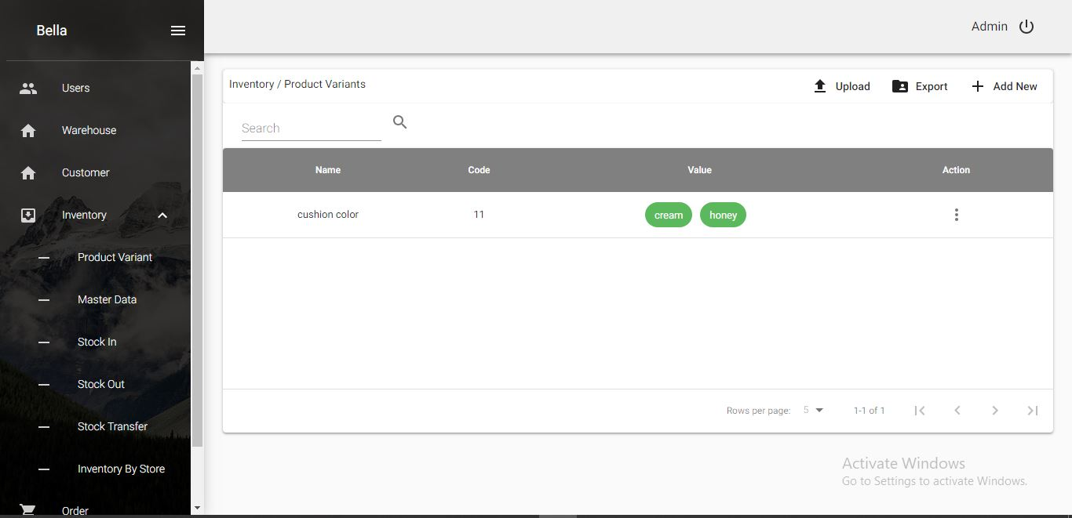

**Figure 3.9 Product Variant List**

For the second step of creating products with variants, user have to fill stock keeping unit, price and respective variant values for each product.

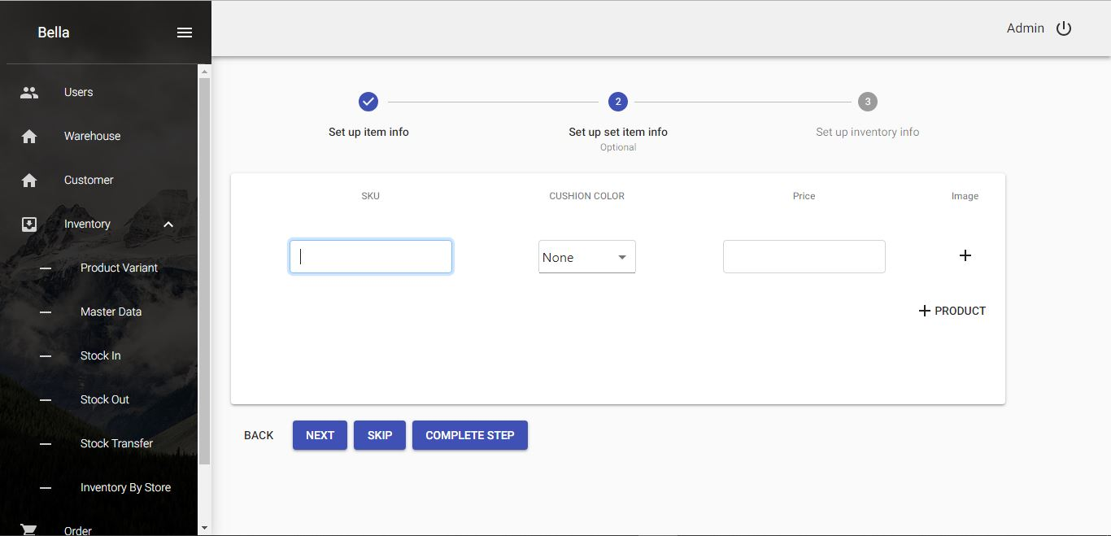

**Figure 3.10 Step 2 of product creation with variant**

After creating products in the system, user can use inventory management services. On arrival of new products into the real world inventories, user can add them into the system, too. Firstly, user have to select arrival products defined in the system. Stock keeping units written in blue color can be clicked to show details of the product such as quantity in the inventory, price, and variants.

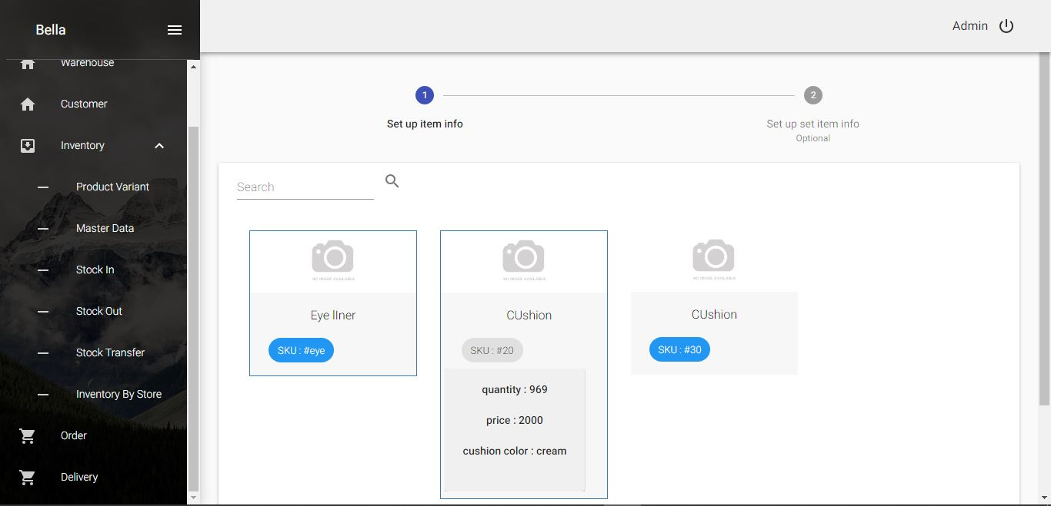

**Figure 3.11 Step 1 of Stock-In form**

After choosing products, user have to fill information such as voucher number, date, destination warehouse and quantity of each product as shown in Figure 3.8.

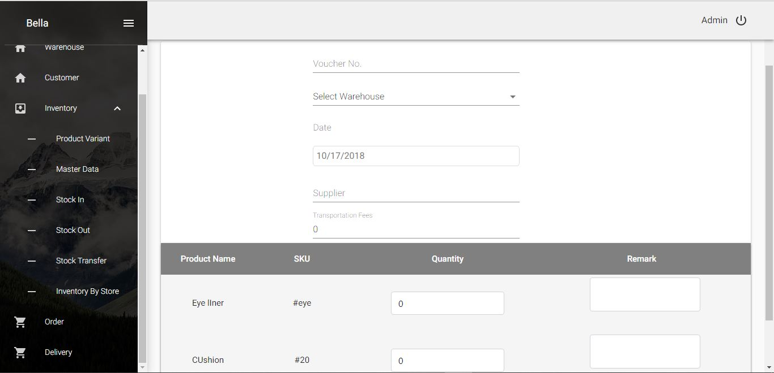

**Figure 3.12 Step 2 of Stock-In form**

Then, user can see all stock-in records in the table. Blue colored stock keeping unit can also be clicked to show product variants details but uncolored stock keeping unit cannot be clicked because it has no variants.

User can see all stock-in records in the table. Blue colored stock keeping unit can also be clicked to show product variants details but uncolored stock keeping unit cannot be clicked because it has no variants.

If user want to remove some products form his inventories for some reasons (e.g. giving presents to someone, lost products, damaged products), he can also remove in the system by clicking ‘Stock Out’ menu which features are the same as ‘Stock In’ menu but it has to choose warehouse first. Then, products from chosen warehouses can be selected for removal purpose.

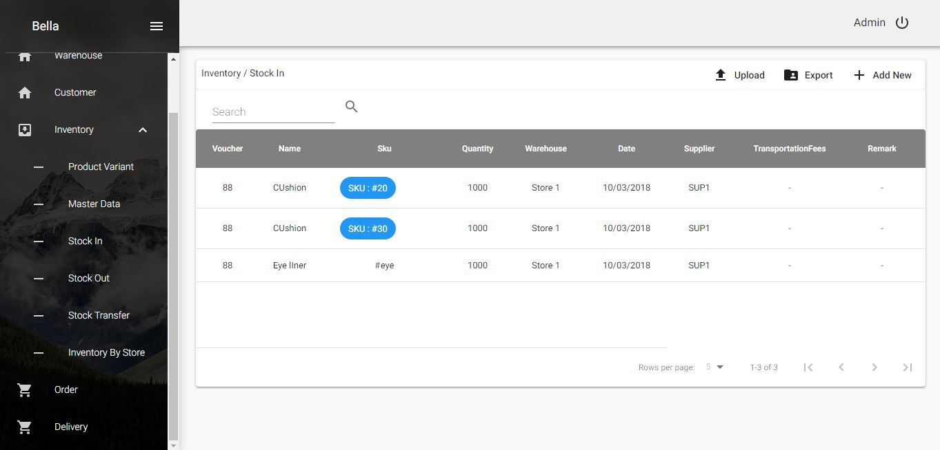

**Figure 3.13 Stock-In List**

When user want to move his products from one warehouse to another, he can do it in the system by clicking ‘Stock Transfer’ menu. Firstly, user have to choose warehouse. Products of selected warehouse are appeared in the screen, then select products. After that, user have to select to hold transferred products and fill information such as date, voucher number, and quantity of each products. User can leave some note for his action, also. For checking balance quantity of each warehouse, user can view in the ‘Inventory by Store’ menu.

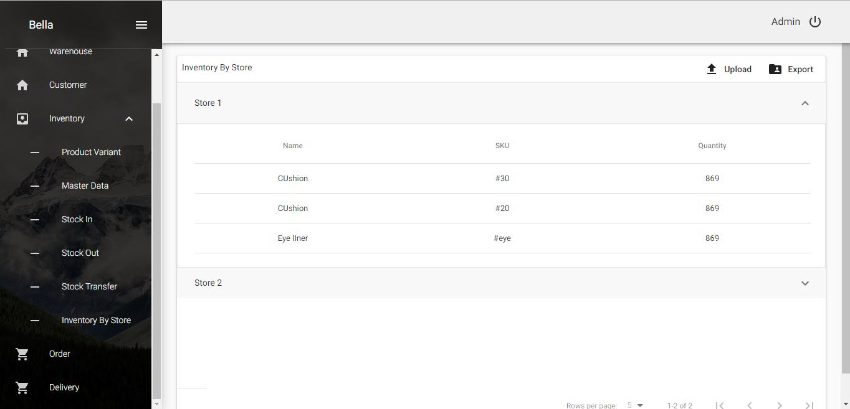

**Figure 3.14 Inventory by Store**

3.2.6 Order Module

User can create orders from respective warehouses in the ‘Order’ menu. Products from assigned warehouses are appeared in the screen. User have to pick products to order and fill information such as date, quantity of the product and customer. If the customer is new and not appeared in the dropdown selection, user can create new customer by adding customer address, and phone number. Next time, user do not have to re-enter the customer information again. He can easily select from the dropdown list. If the order needs delivery, user have to check ‘Need Delivery’ checkbox.

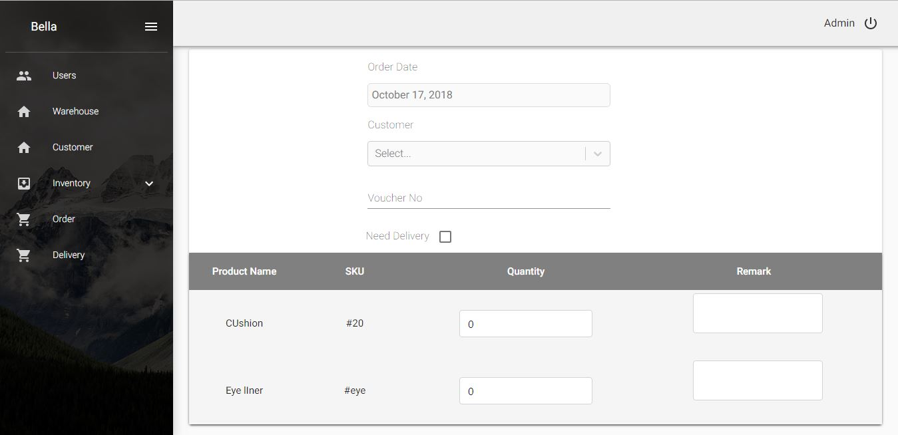

**Figure 3.15 Order Form**

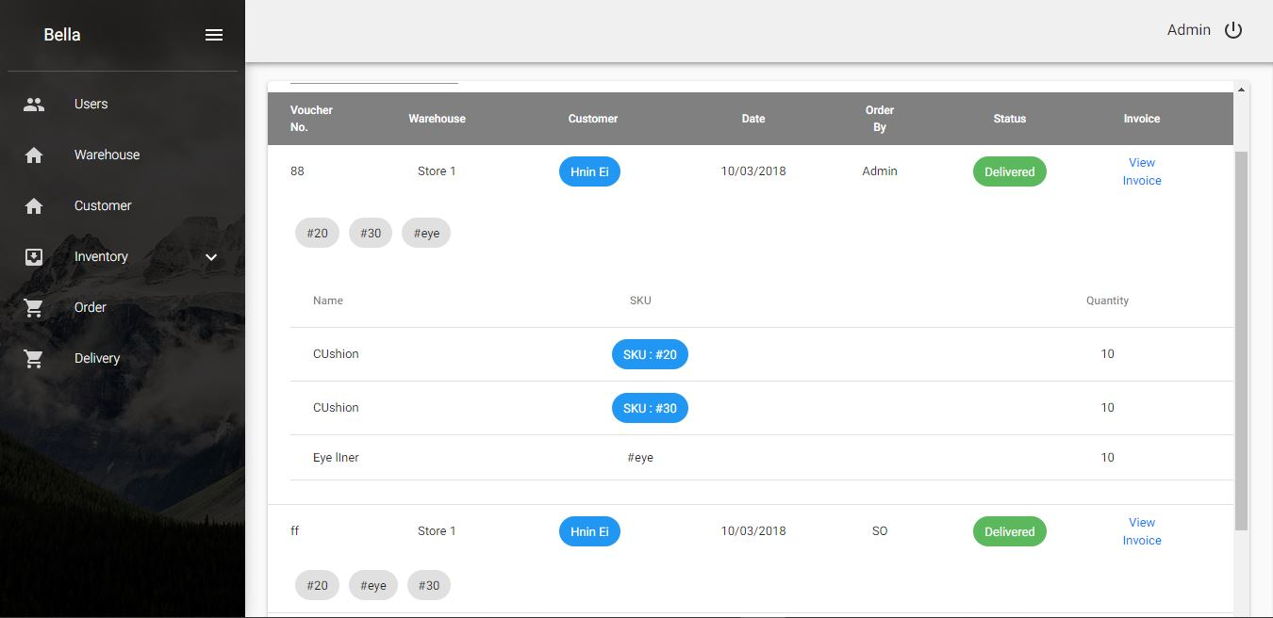

**Figure 3.16 Order Detail**

Orders are shown in the table. Details of each order can be shown by clicking down arrow at the right corner of table row. If order needs delivery not delivered yet, they are appeared with status ‘To Deliver’ with gray color. After delivery, they will be changed into ‘Delivered’ with green color as shown in figure 3.12.

Delivery man and fee are also appeared automatically. Details of delivery man such as address and phone can be viewed by clicking blue colored name. User can also get invoices by clicking ‘View pdf’ link. He can either download or print them and send to customers in real world.

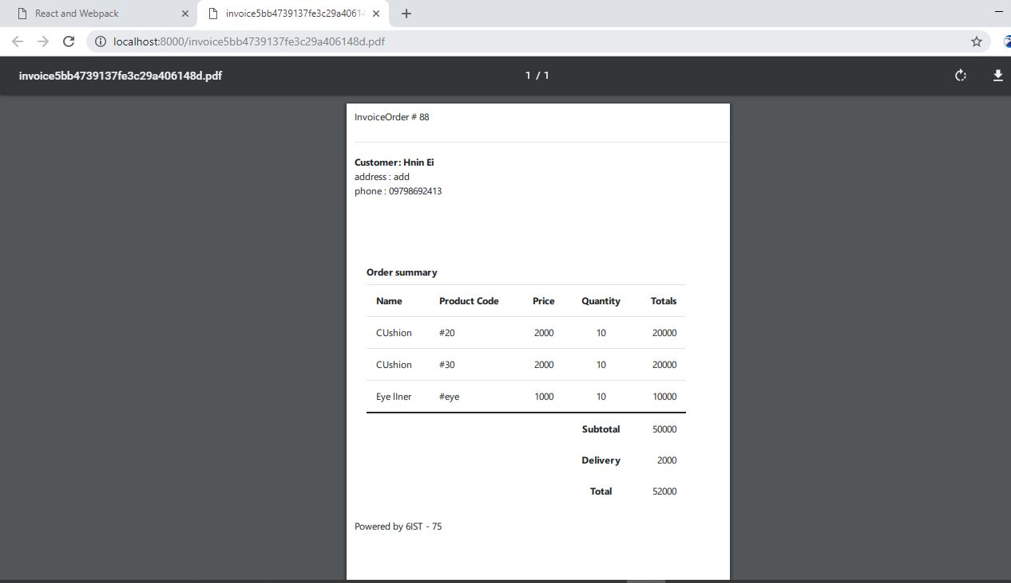

**Figure 3.17 Invoice PDF**

3.2.7 Delivery Module

Orders which need delivery service are appeared in the ‘Delivery’ module. When delivery man get ready to deliver, he must click ‘Deliver’ button. He must fill delivery fee in the dialog box. After that, the system will mark them as delivered orders. Delivered orders are appeared in the order list with status ‘Delivered’ with green color.

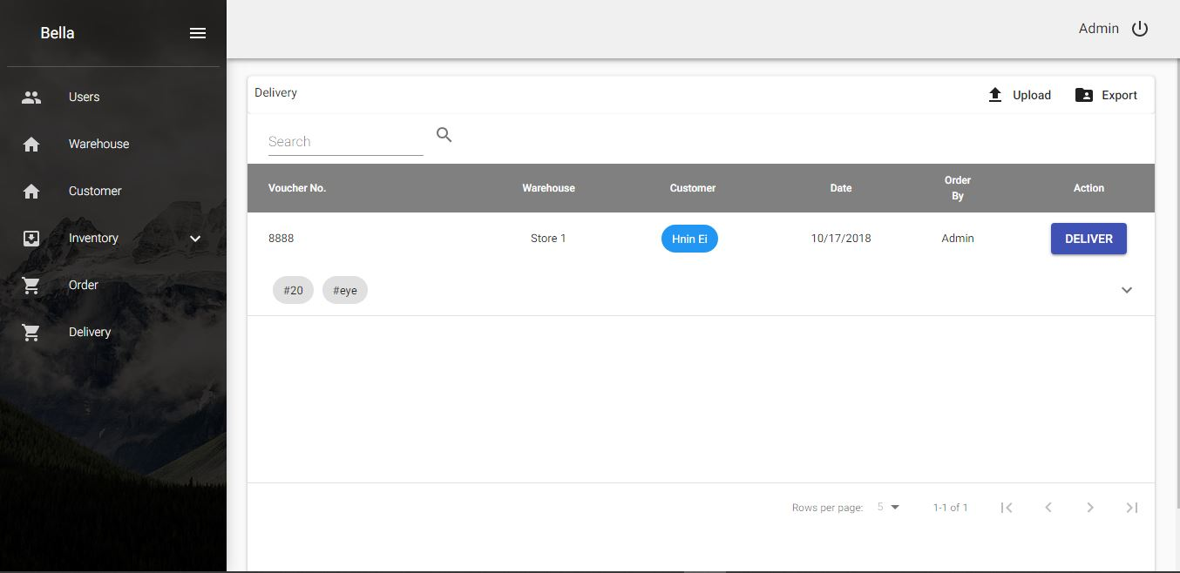

**Figure 3.18 Delivery List**

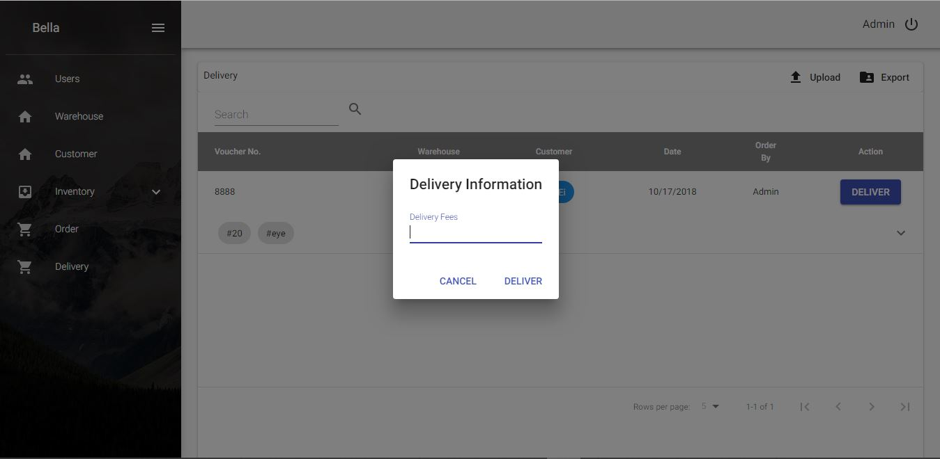

**Figure 3.19 Delivery Fee**

**3.3 Transportation Company**

This system provides the following services for the transportation company.

1. User Management
2. Bus and Township Setting
3. Ticketing Module
4. Ticket Sale Module
5. Sold Tickets Module
   * 1. User Management (Employee management)

User Management module is the same as that of distribution companies.

* + 1. Setting

For transportation companies, user have to create his real world buses in the system. User have to enter car name (e.g. First Class, Ordinary Class, Super Seat, etc.). Then, car information such as plate number, number of seats and number of seats per row. After that, user have to define his seat name order from the dropdown list. The system support popular seat order described below.

* 1. 1, 2, 3, etc.
  2. A1, A2, A3, etc.
  3. 1A, 1B, 1C, etc.

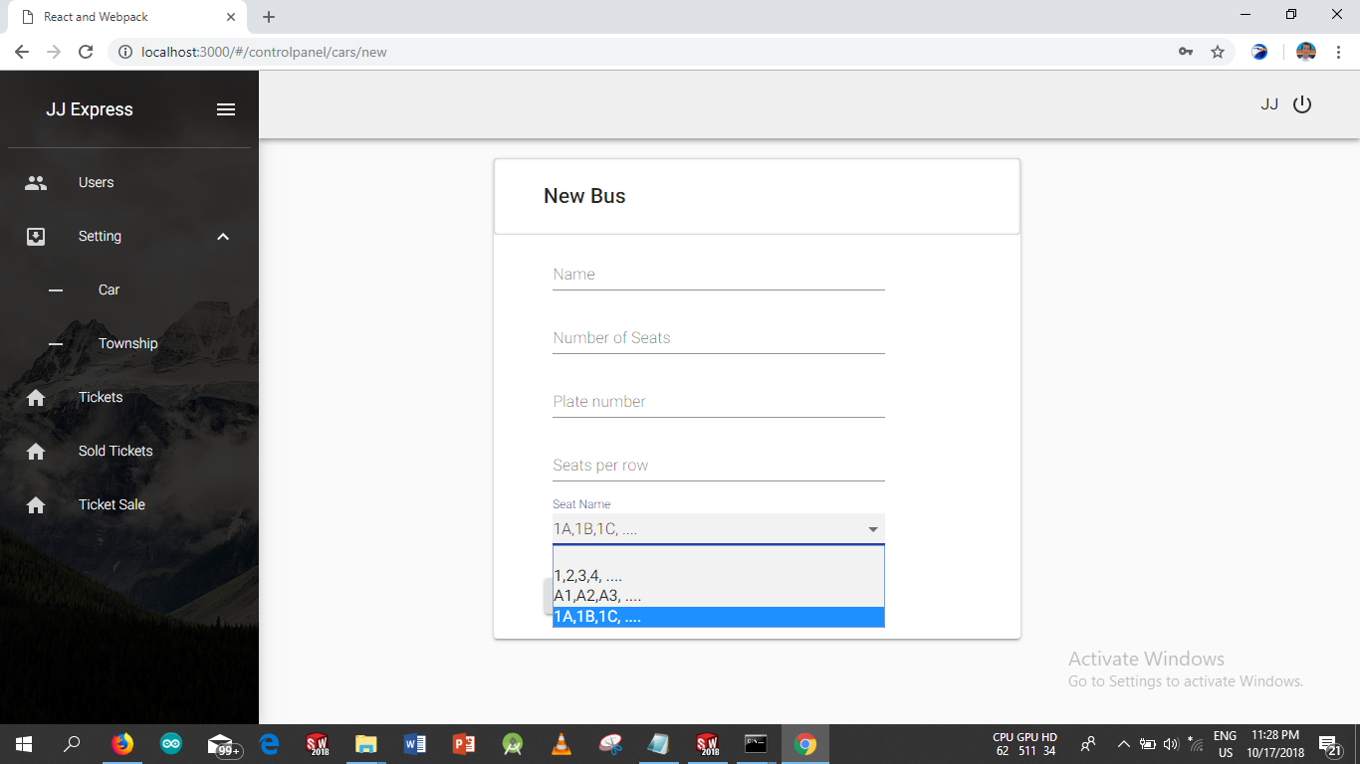

**Figure 3.20 New Bus Entry**

After adding buses into the system, user can see all of his buses in the ‘Car’ menu.

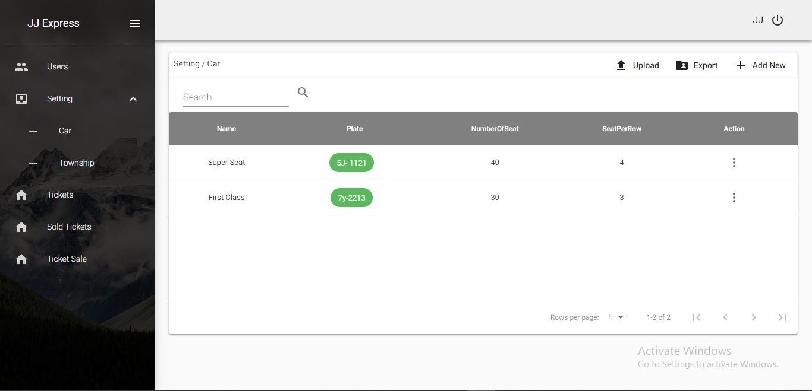

**Figure 3.21 Bus List**

After adding buses, user have to define townships for their bus routes. Once he defined in the system, he can edit or delete them.

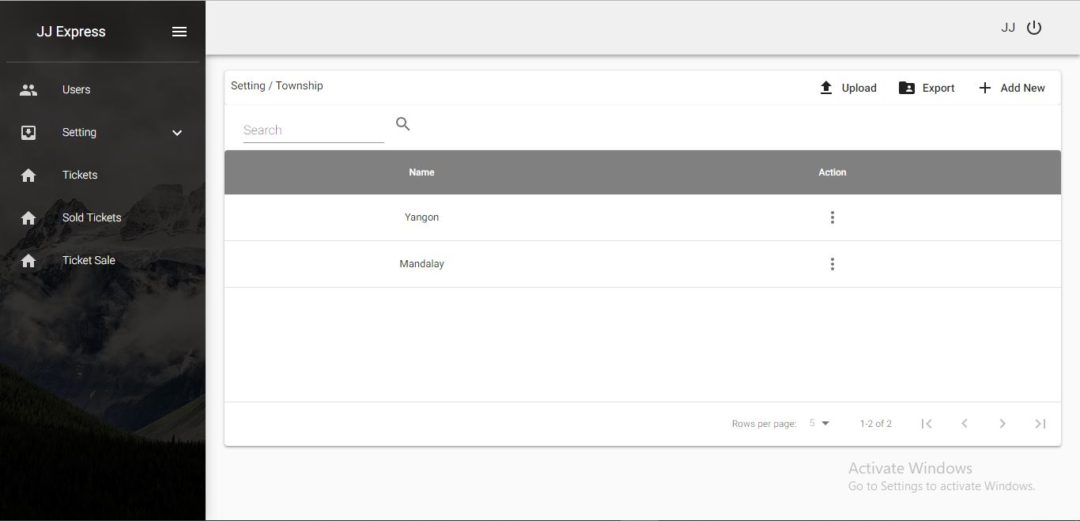

**Figure 3.22 Township List**

3.3.3. Ticketing Module

Before user can sale tickets, he must first generate tickets in the system. This can be done in the ‘Tickets’ module. Firstly, user have to choose bus number. After that, user have to define departure time, price, destination city and source city.

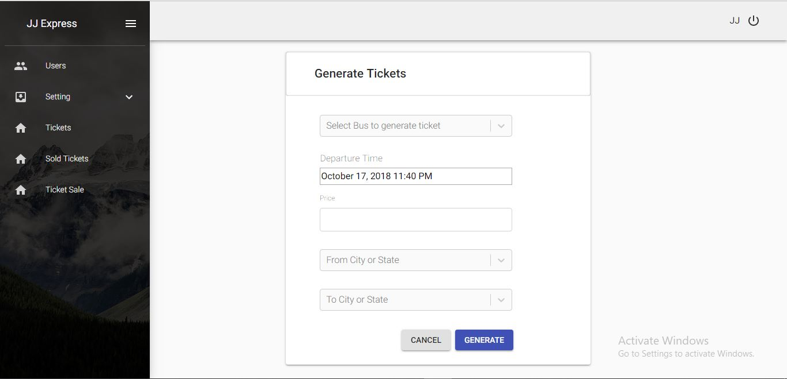

**Figure 3.23 Generate Ticket**

After generating tickets, user can check tickets of which routes are generated in the table.

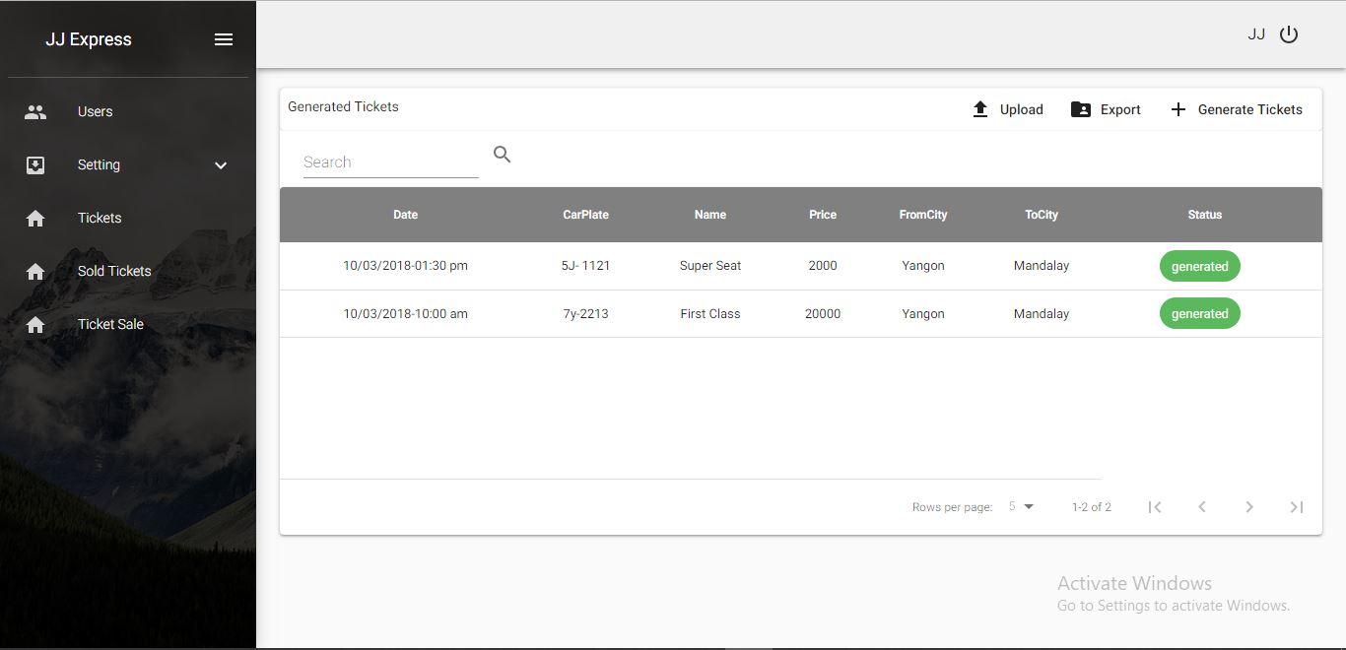

**Figure 3.24 Generated Ticket**

3.3.4. Ticket Sale Module

In the ticket sale module, user must choose departure date, destination city and source city. If tickets for that route and time have been generated, user will see buses with name, price and departure time on the screen.

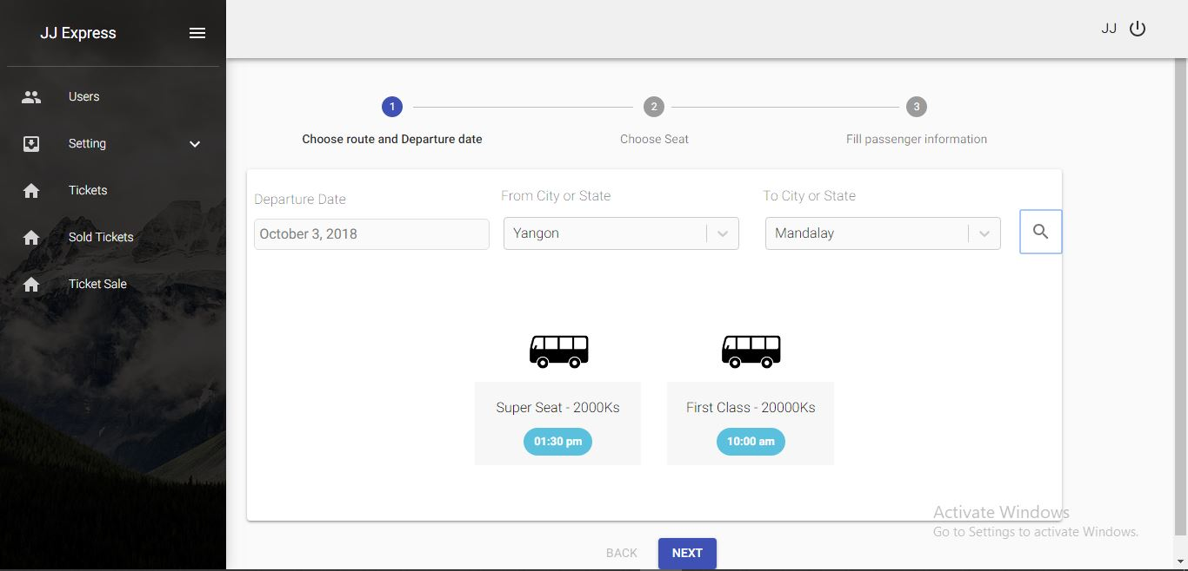

**Figure 3.25 Step 1 of Ticket Sale**

After choosing a bus to book, user have to select seats. Green seats are available to book and red are already occupied seats. Already occupied seats are shown with lady, gentle man and group icons so that user can easily decide which seat should be ordered.

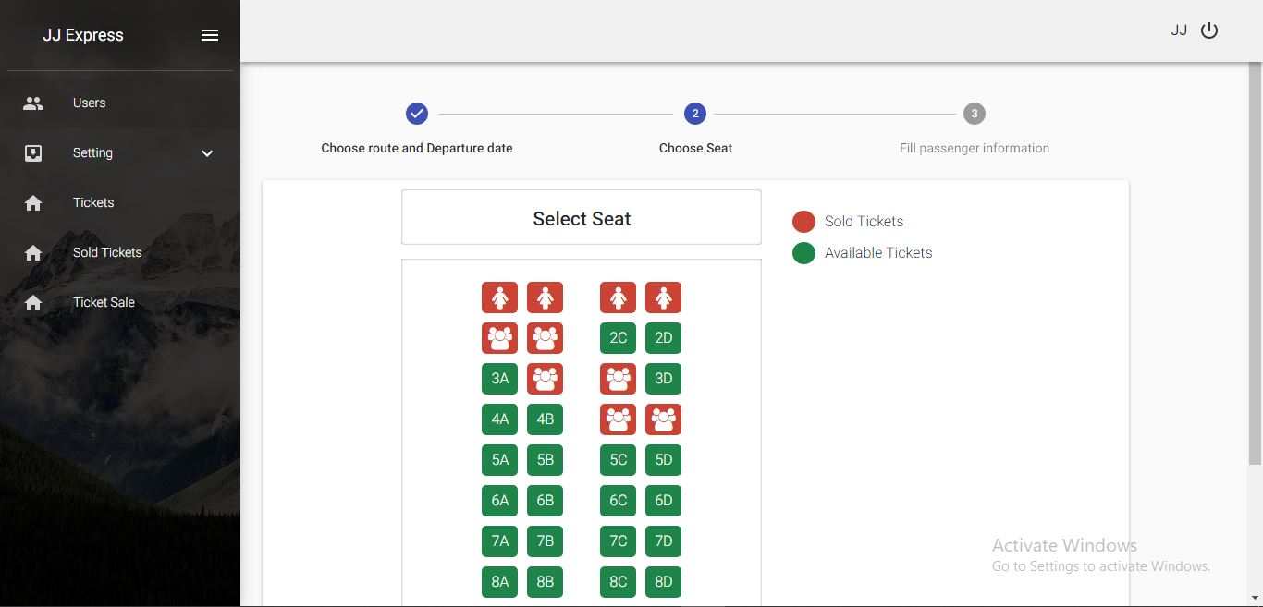

**Figure 3.26 Step 2 of Ticket Sale**

After choosing seats, user have to fill required passenger information such as NRC, phone number, etc. in the third step.

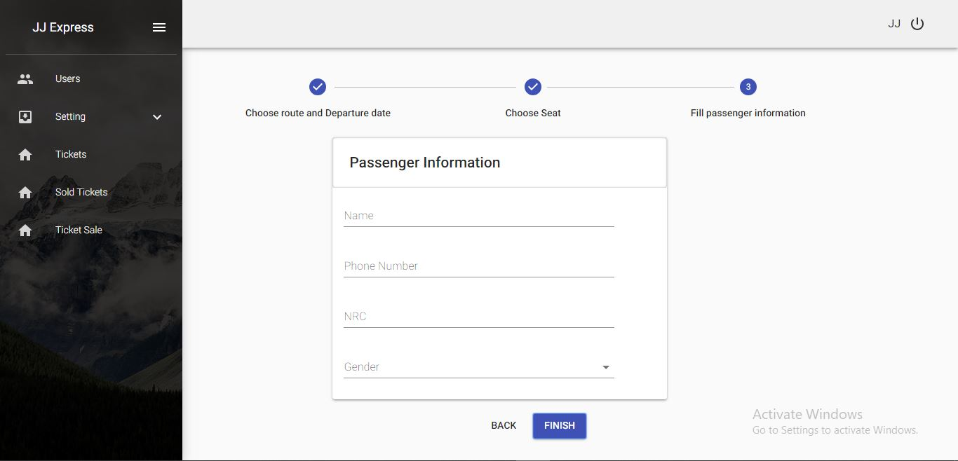

**Figure 3.27 Step 3 of Ticket Sale**

3.3.5. Sold Tickets Module

After booking, user can see which tickets have been sold out by clicking   
‘Sold Ticket’ menu. To give passenger a paper ticket, user can get instant ticket from the system by clicking ‘View pdf’ link in the system. User can either download or print to give passenger a ticket paper.

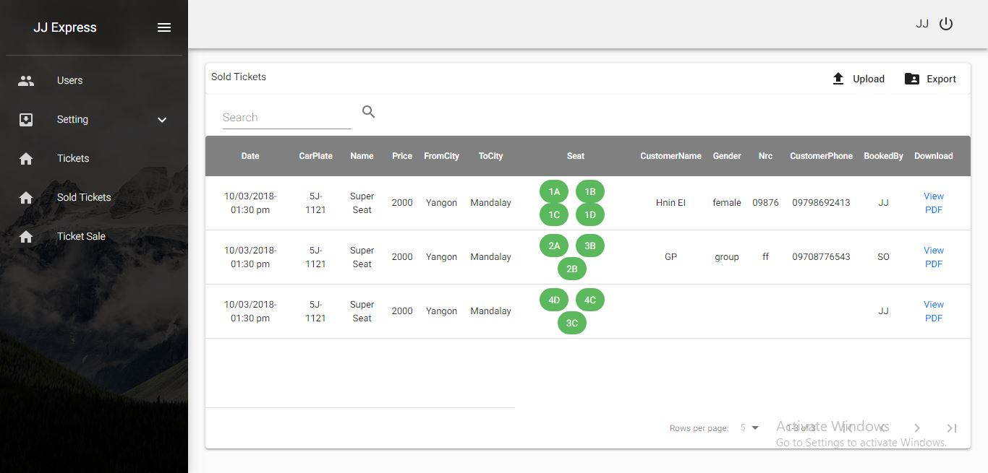

**Figure 3.28 Sold Tickets List**

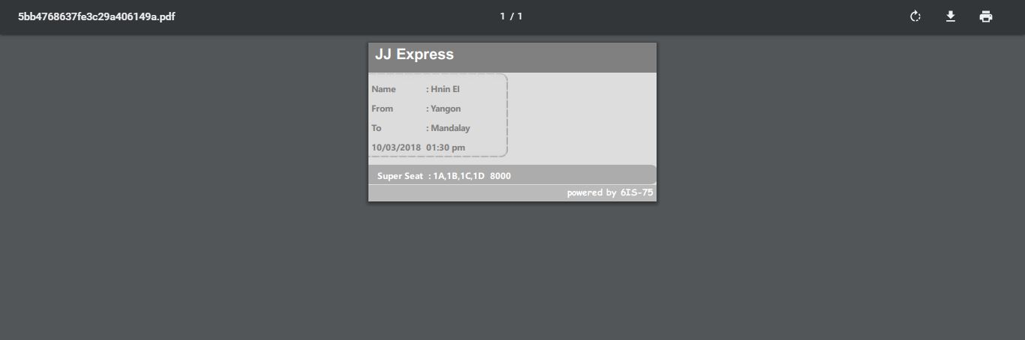

**Figure 3.28 Ticket PDF**

According to user roles, not all users can access all modules in the system. Authorities for each role are defined in the table below.

**CHAPTER 4**

**CONCLUSION**

A survey on various color models, their description, comparison and evaluation result is presented. These models used various components of an image to display on specific hardware platform. The purpose of a color model is to facilitate the specification of colors in some standard generally accepted way. Research work also shows the conversions of various models to speed up the image processing with least time delays. But there is invariance in results of various models due to complex mathematical equations. In future, various image processing methods i.e. adaptive histogram equalization and contrast limited adaptive histogram equalization can be used to speed up the image processing by using these color models. This system shows how to retrieve the desired color from the video file by tracking the color using HSV color space. Color tracking is important in image segmentation, monitoring and security issue. The proposed system can be tracked the desired color in the video clip.

**4.1 SWOT analysis**

**Table 4.1 SWOT Analysis on the system**

|  |  |
| --- | --- |
| **Strengths** | 1. Low Cost 2. Flexible 3. Easy Customization 4. Scalable |
| **Weaknesses** | 1. Customer training 2. Support only two types of companies for now. |
| **Opportunities** | 1. New platform in the market |
| **Threats** | 1. Customer knowledge |

Because of developing in SaaS model, this system must available in low cost. If user want to use this system, he can get over the cloud, easily. If he want to drop, he can do it by not renewing the payment after expiration. This will be strengths of the system.

Because it is in SaaS model, user cannot be supported with customer training like on premise solutions. This would be threats of the system. Because of not enough customer training, user who do not have enough knowledge will be afraid of using this system. This can be weakness of this system.

As this system is new to the market, and it is available in the cheapest price, this would be an opportunity for the system.

**4.2 Limitation**

This system have only four user roles for distribution companies and three roles for transportation companies. For the transportation companies, this system can provide only three types of popular order.

Because of developing in software as a service model, this system needs a configuration by admin himself.

This system is not ready yet to support all types of businesses, but for two types (distribution companies and transportation companies).

**4.3 Further Extension**

This system will be upgraded to support customize user roles and customize authorities for each user roles. For the transportation companies, this system will support customize seat orders, later.

Then, this system will be improved by adding payment subscription module. Users who want to use this system have to select subscription packages. After the admins of this system will take required checking, user will be sent an validation email. Then, user can start using this system. After subscription gets closer to expire, user will receive an email about his subscription. He would be able to drop his subscription or renew it. Figure 4.1 shows subscription packages.

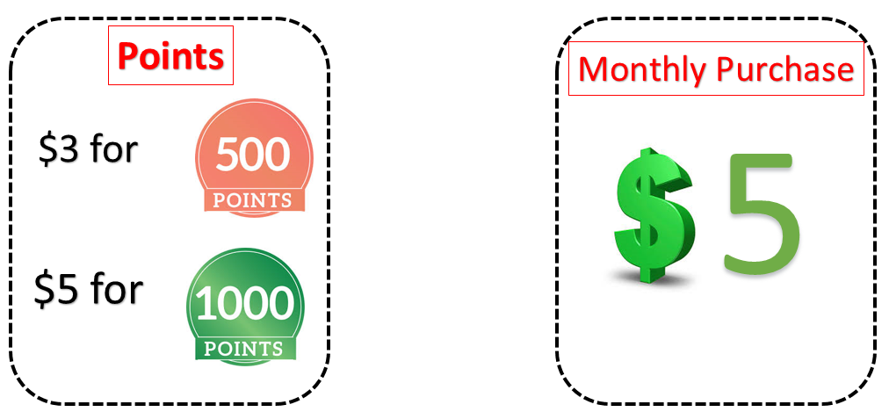

**Figure 4.1** **Point-based packages and Monthly packages**

For future, this system can be added more frameworks for other business types. Because of modular features, this system will be able to let users choose their customize services and build a customize framework.